**Journey Through The Bible**

**Simon Peter**

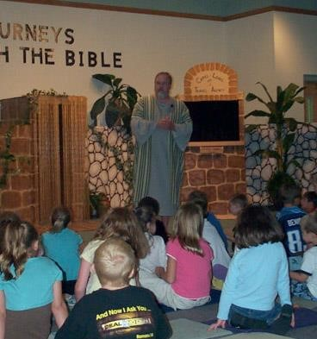

My name is Simon Peter, Jesus gave me my name, but call me Peter. I am visiting in a city called Joppa with a friend who is also called Simon.

One day, I went to pray, and while I was praying, God showed me a big sheet. It seemed to come down from Heaven by its corners, and I saw that it held all kinds of animals, creeping things, and birds. And God told me to get up, kill something, and eat.

I said, “No.” I don’t eat unclean things. But God said that these were not unclean because he had cleaned them. God showed me this three times.

When I looked up, I saw these men who had been sent from another place called Caesarea, to get me and bring me to a man called Cornelius. God said for me to go. When we got there Cornelius, a good man who feared God and a Gentile, told me that an angel told him to send for me. He fell at my feet, but I told him to stand-up, for I am just a man.

Jews are not to go into the houses of Gentiles, but I did. I told Cornelius that God loves all men. So I preached to him, and told him about Jesus and how he healed people. I told him how Jesus was killed and how God raised him on the third day. I told Cornelius how Jesus was seen by many people after he was raised from the dead. I

said that I had seen him and had eaten with him. I said that whoever believes in Jesus will be forgiven of their sins.

Cornelius and the other Gentiles who were there were overcome with the Holy Spirit. They began to speak in tongues and to glorify God. They wanted to be baptized, and I thought they should because they had the same rights as the Jews.

We baptized them. There are no unclean people in the sight of God just like God said there were no unclean animals in the sheet.

Cornelius and his friends asked me to stay a few days. They had become the first Gentile Christians. Remember my story from the book of Acts. Now I would like to ask you some questions. (Prepare a few questions to ask the boys and girls about your character).

**Scripture reading**: Acts 10:9-47

**Memory Verse:** Romans 1:16

I am not ashamed of the gospel (Bible)